Artificial Intelligence Notes
Lecture 01
What is AI?
AI (Artificial Intelligence) is when computers are made smart enough to do things that usually need human thinking, like learning, solving problems, understanding language, and recognizing pictures. It helps machines act more like humans.
Think like humans and act like humans?
Think Like People
- AI tries to copy human thinking (learning, problem-solving, memory).
- Example: ChatGPT learns from conversations like a human.
Act Like People
- AI behaves like a human (talking, recognizing faces, driving cars).
- Example: Robots like Sophia can talk and express emotions.
Think Like Rationally and Act Like Rationally?
Think Rationally
- AI follows logic and reasoning to make the best decisions instead of emotions or guesses.
- Example: Chess AI analyzes moves and picks the smartest one.
Act Rationally
- AI makes smart choices to achieve goals efficiently.
- Example: Self-driving cars follow traffic rules to avoid accidents.
Perspective on AI:
Perspective: Means different ways of looking at or understanding something.
- Skill Based Perspective
This perspective says that intelligence is about getting better at specific tasks. It focuses on practical abilities rather than general thinking.
Example:
Imagine you are learning how to fix a car.
- At first, you don’t know much.
- Over time, you practice and improve.
- Eventually, you can fix any car problem easily.
That means you have gained intelligence in car repair—because you learned and mastered a skill.
In short:
Skill-Based Perspective = Intelligence is about getting better at tasks like fixing cars, coding, or playing chess.

- Embodiment Perspective
This idea suggests that intelligence requires a body to interact with the real world. It believes learning happens through physical experiences, not just thinking.
Example:
A robot learning to walk

- A robot can't just learn to walk by watching videos or simulations.
- It must physically try walking, fall, adjust, and learn from experience.
- This means intelligence isn't just in the brain, but in physical actions too.
Summary:
Learning is more effective through physical experiences, not just theory.

- Psychometrics Perspective (Measuring Intelligence)
This perspective measures intelligence using tests like IQ tests. It focuses on numbers and scores to understand mental abilities.
Example:
IQ Test
- A test that checks memory, problem-solving, and language skills.
- If someone has an IQ score of 140, they are considered very intelligent.
Summary:
This perspective sees intelligence as something that can be measured using scores.
- Human-Compatible Perspective (AI Should Help Humans)
This perspective focuses on creating AI that understands and helps humans safely and effectively. The goal is to build machines that align with human needs and values.
Example:
Virtual Assistants (Siri, Google Assistant)
- These AI tools listen to human commands and assist with daily tasks.
- They are designed to be useful and safe, rather than making decisions on their own.
Summary:
AI should be designed to work with humans and assist them safely.

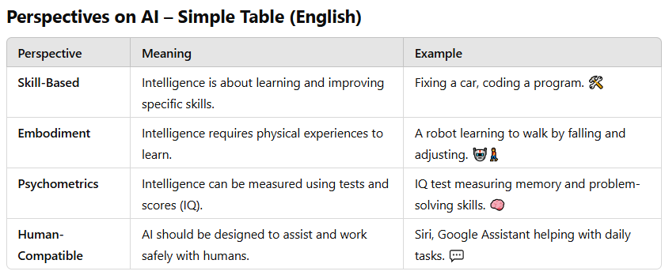

Understanding the Brain & AI
Brains are good but not perfect at rational thinking
- Humans can make smart decisions, but sometimes we make mistakes due to emotions or biases.
Brains Are Complex, Not Like Software
- Software is like LEGO blocks—you can break it into small parts, fix one piece, and put it back together.
- The brain is like a tangled ball of wires—everything is connected, so you can’t easily take out or fix just one part.
- In simple words the brain is not built in separate sections like software—everything works together, making it hard to understand or copy.

AI is better than humans in some tasks
- AI can calculate faster, store more data, and work non-stop.
- Example: Chess AI beats human champions because it processes millions of moves in seconds
Brains vs. AI is like Wings vs. Flight 🦅✈️
- Birds use wings to fly, but airplanes fly differently and even better in some ways.
- Similarly, AI doesn’t need to work exactly like a human brain to be intelligent.
We can’t build AI as powerful as the brain (yet!) 🚀
- The human brain has around 86 billion neurons, and AI is not that advanced yet.
- But we keep improving AI models over time.
The Brain is a great inspiration for AI 💡
- Even though AI is different, scientists study the brain to make better AI systems.
History of AI
1940-1950: Early days: neural and computer science meet
- 1943: McCulloch & Pitts: Boolean circuit model of brain
- 1950: Turing's “Computing Machinery and Intelligence”
1950—70: Excitement! Logic-driven
- 1950s: Early AI programs, including Samuel's checkers program, Newell &
- Simon's Logic Theorist, Gelernter's Geometry Engine
- 1956: Dartmouth meeting: “Artificial Intelligence” adopted
- 1965: Robinson's complete algorithm for logical reasoning
1970—90: Knowledge-based approaches
- 1969—79: Early development of knowledge-based systems
- 1980—88: Expert systems industry booms
- 1988—93: Expert systems industry busts: “AI Winter”
1990—: Statistical approaches
- Resurgence of probability, focus on uncertainty
- General increase in technical depth
- Agents and learning systems… “AI Spring”?
- 1996: Kasparov defeats Deep Blue at chess
- 1997: Deep Blue defeats Kasparov at chess
2010-2017: Big Data, GPUs, Deep Learning
- 2011: Apple releases Siri
- 2012: Alex-Net wins ImageNet competition
- 2015: DeepMind achieves “human-level” control in Atari games
- 2016: DeepMind’s AlphaGo defeats Lee Sedol at Go
- 2016: Google Translate migrates to neural network
2017—: Scaling Up, Large Language Models
- 2017: Google invents Transformer architecture
- 2017: Deep-Stack/Libratus defeat humans at poker
- 2018-2020: AlphaFold predicts protein structure from amino acids
- 2021-2022: Modern text-to-image generation
- 2022: OpenAI releases ChatGPT
- 2024: Every other company also releases a chatbot
Lecture 02
Agent:
An agent is anything that can sense its surroundings and take actions based on what it senses.
Sensors = Eyes & Ears 👀👂
- These help the agent see, hear, or detect what’s happening.
- Example: A self-driving car has cameras, radar, and GPS as sensors.
Actuators (Effectors) = Hands & Feet 🤖🏃‍♂️
- These let the agent take action and change things in the environment.
- Example: A robot’s wheels or arms help it move or pick up things.
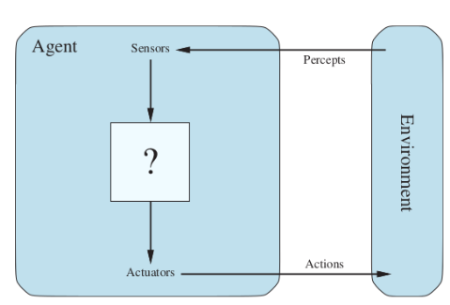
Types of Agents:
- Human Agent:
A human agent has sensory organs such as eyes, ears, nose, tongue and skin parallel to the sensors and other organs such as hands, legs, mouth, for effectors.
- Robotic Agent
A robotic agent uses cameras and infrared sensors to see and detect objects, just like human eyes. It uses motors and other moving parts to act and move, just like human hands and legs.
- Software Agent
A software agent gets input from the keyboard, files, or internet data (just like human senses 👀). It acts by showing things on the screen, saving files, or sending messages over the internet (like speaking or writing ✍️).
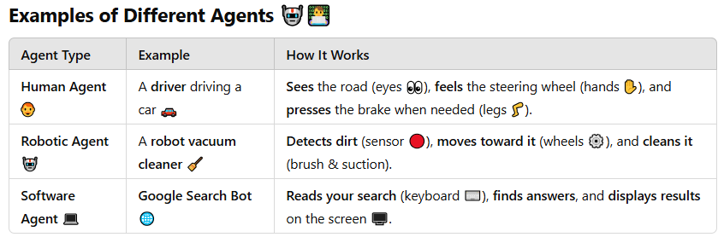
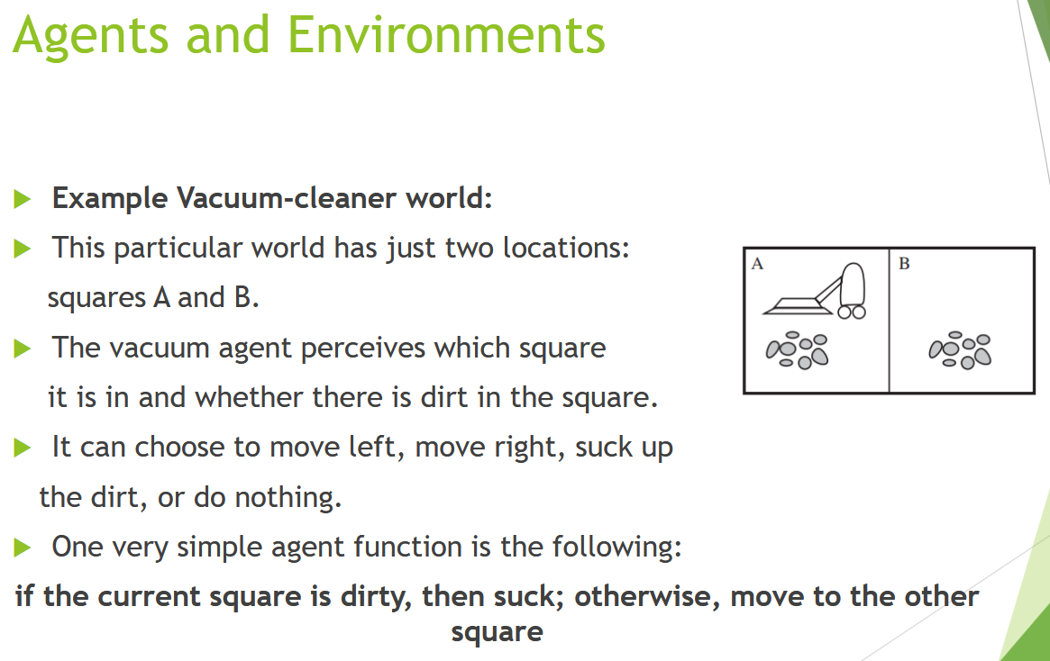
Concept of Rationality (in Simple Words)
Rationality means making the best possible decision based on what you know to achieve a specific goal. A rational agent is one that does the "right thing" in a given situation.
But what does "right thing" mean here? 🤔
It doesn’t mean perfect decision-making—it means making the best decision based on the available information, past experience, and the agent’s goals.
Example:
Imagine you're playing a video game where you need to avoid obstacles and collect coins.
- If you see a coin and move toward it, that’s rational.
- If you see an obstacle and avoid it, that’s rational.
- If you ignore a coin or hit an obstacle when you could have avoided it, that’s not rational.
In short: Rationality means taking actions that help you win the game using what you know.
COR (Continue):
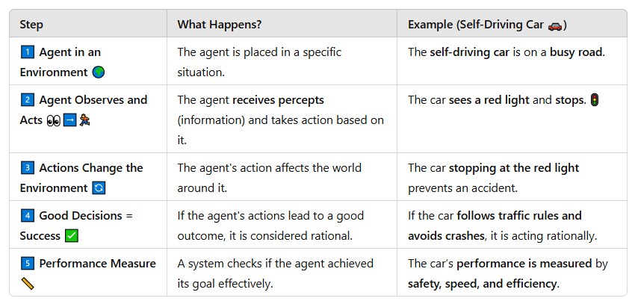
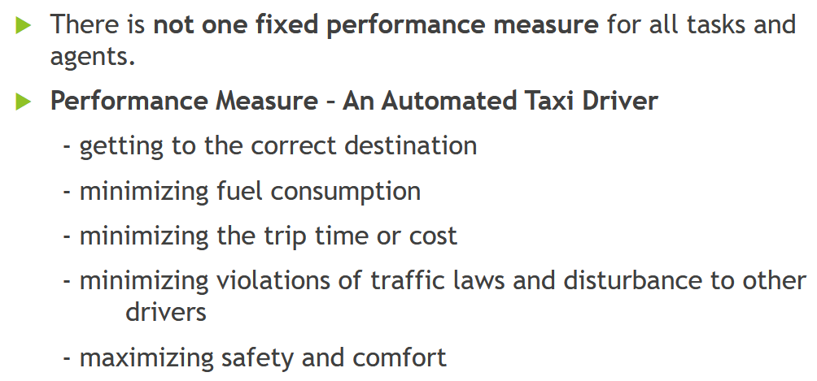

Rational Agent:
A rational agent is a system that always tries to make the best decision based on the information it receives. It observes its surroundings (percepts), processes this information, and then selects the most effective action to achieve the best possible result. The agent uses both its current observations and any built-in knowledge it already has to make smart choices. Its goal is to maximize success by taking actions that lead to the best performance.
Example:
A self-driving car detects a red light, knows from its training that stopping is the safest option, and applies the brakes to avoid accidents. This decision-making process ensures that the agent behaves logically and efficiently in any given situation.
What is Task Environment?
The Task Environment is everything an agent interacts with and operates within to achieve its goals. It includes:
- The world around the agent (the environment).
- The tasks it needs to accomplish.
- The tools it uses to perceive and act (sensors & actuators).
PEAS Framework (to define task environments)
PEAS stands for:
- P – Performance Measure: How we measure success.
- E – Environment: The surroundings the agent works in.
- A – Actuators: Parts that act or change the environment.
- S – Sensors: Parts that perceive or gather information.
🚗 Example: Self-Driving Car
- Performance Measure: Safe, efficient, and legal driving.
- Environment: Roads, traffic, weather conditions.
- Actuators: Steering, brakes, accelerator.
- Sensors: Cameras, GPS, radar.
The task environment guides the agent’s behavior based on these elements.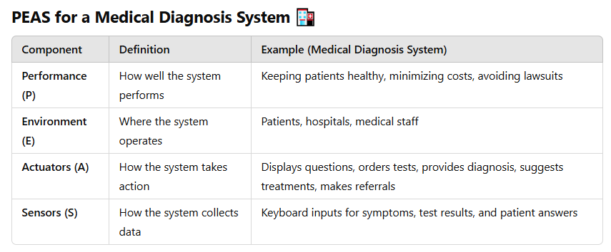
Properties of Task Environment:
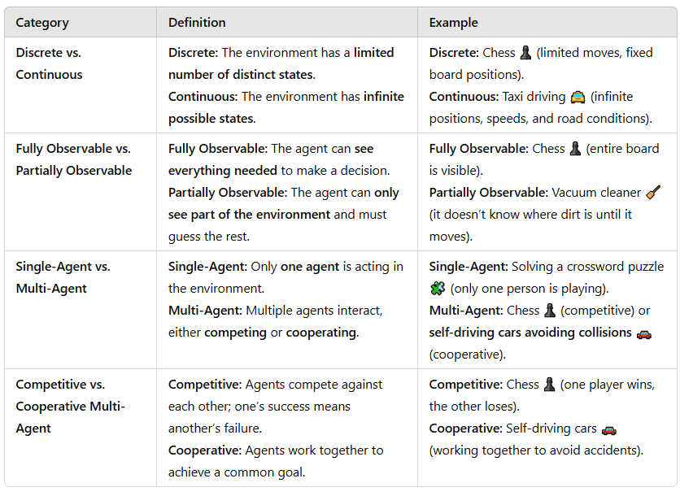
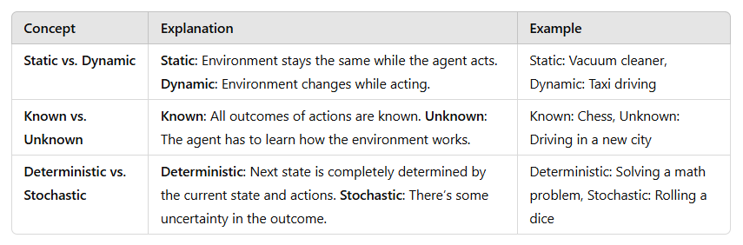
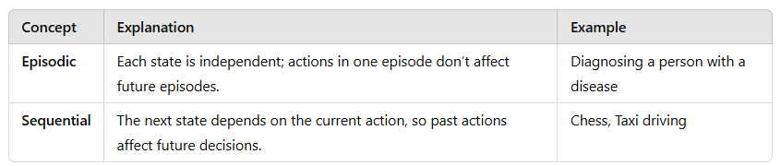
Structure of Agents:
Agent = Architecture + Program
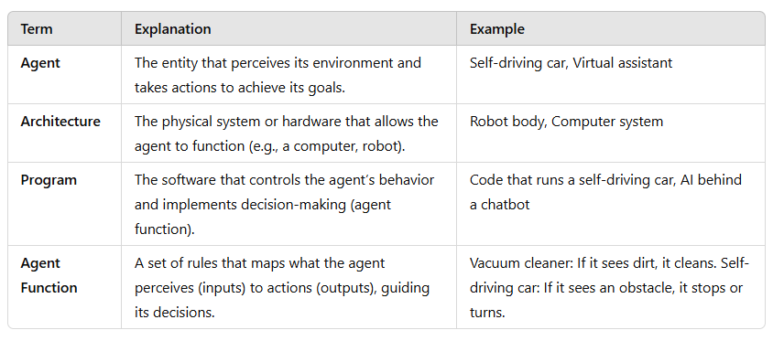
AI’s job is to create an agent program that defines how the agent decides which actions to take based on its percepts (inputs from the environment). This program ensures the agent acts in a way that aligns with its goals.
Architecture:
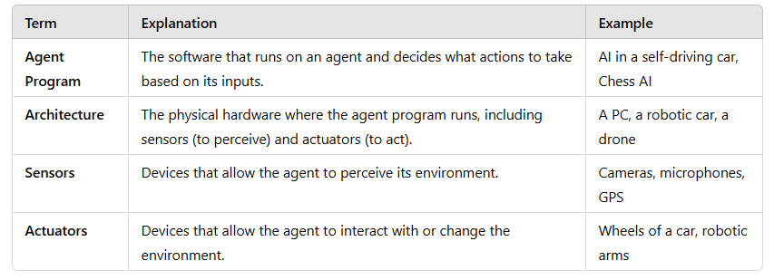

The Structure of Agents – Table Driven
A Table-Driven Agent works like a big lookup table. It remembers everything it has seen (percept sequence) and checks a table to decide what to do next.
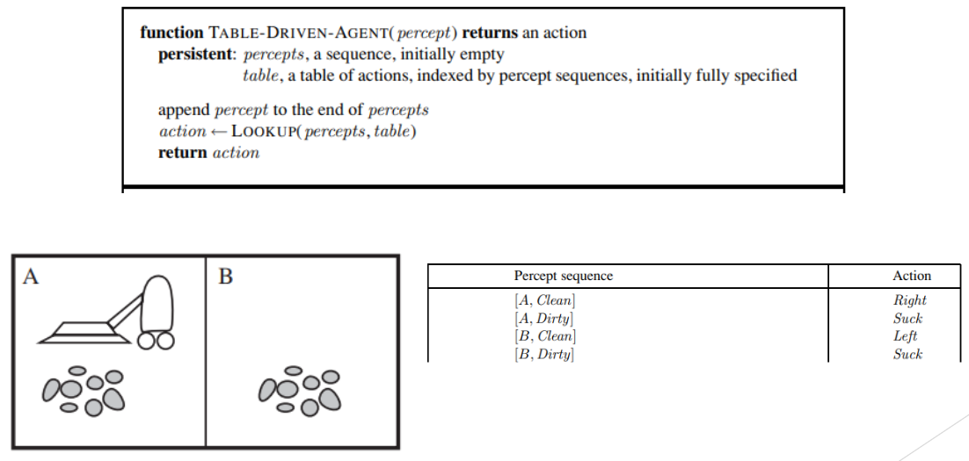
Key Point from Above figure
- Percept: What the agent sees at a moment (e.g., [A, Dirty]).
- Sequence: A list of all past percepts the agent remembers (e.g., [A, Dirty], [A, Clean]).
- Actions: What the agent does based on percepts (e.g., Suck, Move Right).
- Append: Adding a new percept to the sequence (e.g., Adding [B, Dirty] to the list [A, Dirty], [A, Clean]).

Types of Agents:
Simple Reflex Agent
A Simple Reflex Agent works by reacting to what it senses in the environment, without thinking about what happened before. It follows a simple cycle: first, it senses the environment using sensors. Then, it checks a set of rules to decide what action to take. After deciding, it performs the action and repeats the process.
- Example: in the case of a vacuum cleaner, if it senses dirt, it starts cleaning. If the room is clean, it moves to the next room.
- However, the limitation of a simple reflex agent is that it doesn’t remember past actions or learn from them—it simply reacts to the current situation.
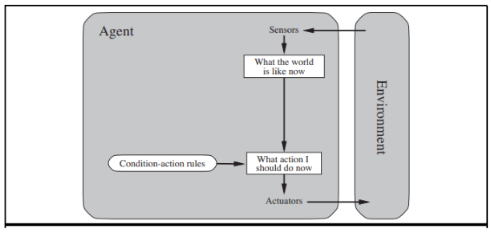
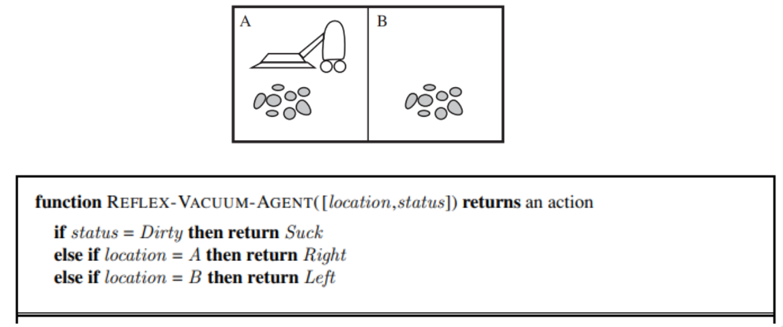
Strengths:
- Simple and easy to implement
- Fast and efficient
- Suitable for well-defined environments
Weaknesses:
- Limited adaptability
- Require a fully observable environment
Model Base Agent
A model-based reflex agent is like a simple reflex agent but with an internal memory of the environment. It can remember past information and use that to make better decisions, especially when it can't see everything around it. This helps the agent react appropriately even if it only has partial information at the moment.
- Example: A self-driving car is a model-based reflex agent. It uses sensors to make decisions, like stopping at a traffic light. If the light is blocked, it remembers the last light color and acts accordingly, even when it can't see the light directly. This helps the car react more intelligently in situations where it doesn’t have complete information.
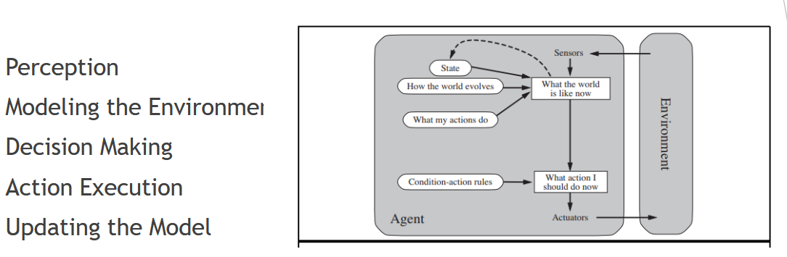
Strengths:
- Handle partially observable environments
- Flexible
- Use internal model to make predictions
Weaknesses:
- Complex
- Relies on internal model
- Limited Learning
Goal Based Agent
A goal-based agent is an extension of a model-based agent, but with an added focus on achieving specific objectives. These agents don’t just react to their environment—they actively plan their actions to reach a goal. They have a clear target or purpose, and they decide the best way to achieve it based on their knowledge and models of the environment.
- For example, a navigation system is a goal-based agent. Its goal is to find the best route to a destination. It constantly evaluates the environment, plans the next steps, and adjusts its actions based on traffic, road conditions, and the destination, ensuring it moves toward the goal efficiently.
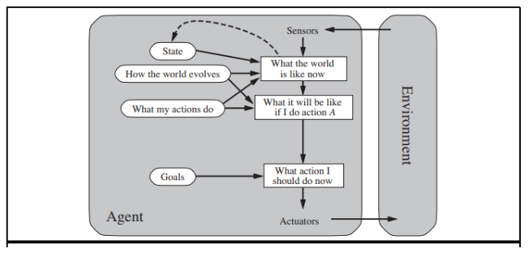
Strengths of Goal-based Agents:
- Adaptability: They can change their behavior depending on the situation, helping them reach their goal even when things change around them.
- Handling Multiple Outcomes: They work well in situations where there are different possible results, making them good for more complicated tasks.
Weaknesses of Goal-based Agents:
- Computationally Expensive: They need a lot of resources to plan and decide the best actions, which can make them slower or more demanding to run.
- Complexity: They are harder to design because they have to plan, make decisions, and keep track of goals all at once.
- Fully Observable Environment: They need to see everything happening in the environment to make the best decisions, so they struggle in situations where they can’t observe everything.
Utility Based Agent:
These agents are like goal-based agents but include utility measurement, allowing them to evaluate and compare different options to choose the best one. This is useful in complex scenarios with multiple alternatives.
- An example of an agent using utility is a shopping assistant in an online store. When you want to buy something, the assistant looks at different products and compares them based on things like price, customer reviews, how quickly they can be delivered, and features. It then recommends the product that gives you the best overall value, based on all these factors.
Strengths of Utility-based Agents:
- Flexible and Adaptive: They can adjust their decisions based on changing circumstances and preferences.
- Incorporate Preferences: They can consider the agent’s priorities, like choosing a faster delivery or a cheaper product, when making decisions.
Weaknesses of Utility-based Agents:
- Complex: They are harder to design because they need to evaluate many factors.
- Computationally Expensive: They require more computing power to compare all the options and calculate the best one.
- Uncertainty: They can struggle when there is uncertainty or lack of information, making it harder to make perfect decisions.
Lecture 04
State Space in AI
In Artificial Intelligence (AI), state space refers to all possible configurations a problem can have. AI systems use state spaces to model problems and find solutions using search algorithms.
Key Elements of State Space in AI:
- Initial State → The starting point of the problem.
- Goal State → The desired outcome or solution.
- Operators (Actions) → The possible moves or transformations from one state to another.
- Path Cost → The cost of reaching a state (if applicable).
- Search Space → The subset of states explored to find the goal.
Example in AI: Solving a Puzzle
🔹 Problem: Solving an 8-puzzle game.
🔹 State Space: All possible board configurations.
🔹 Initial State → The scrambled (random) starting position.
🔹 Goal State: The correctly arranged puzzle.
🔹 Operators: Moving tiles up, down, left, or right.
🔹 Search Algorithm: AI uses BFS, DFS, A*, etc., to find the best path.
State Space Representation in AI
- Graph Representation → Each state is a node, and edges show possible moves.
- Tree Representation → If no state is revisited, AI uses a tree structure.
Role in AI Search Algorithms
AI search methods explore the search space to find solutions efficiently:
- Uninformed Search: BFS, DFS (blindly explore).
- Informed Search: A* Algorithm, Greedy Search (use heuristics to find the best path).

What is Search Space? (Simple Explanation)
Search space is the part of the state space that an AI actually explores to find a solution.
- State Space = All possible situations (too big to check everything).
- Search Space = The specific paths AI explores to reach the goal.
Search Space is divided into three regions:
- Explored = Paths you've already walked.
- Frontier\Fringe = Paths you're considering next.
- Unexplored = Paths you haven’t tried yet.

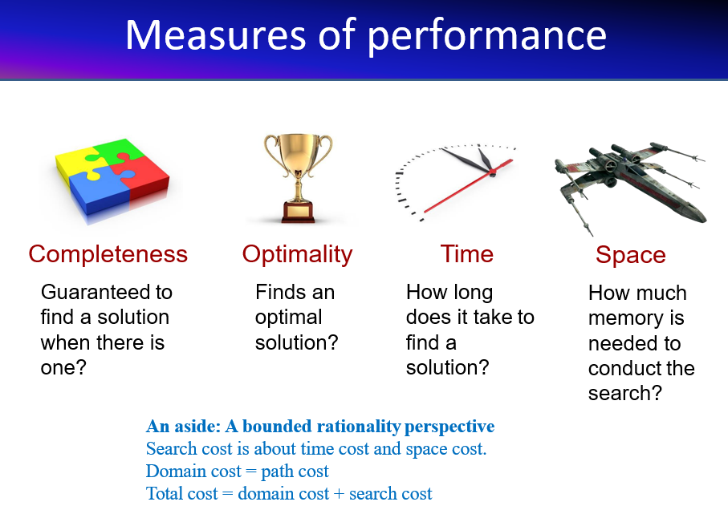
- Path Cost → The total cost of moving from the start state to the goal state
- Search cost = Time spent figuring out the best route.
- Other factors = Time, memory, complexity, heuristics, and real-world obstacles.
- Domain cost = Overall difficulty of solving the problem, including all above factors.
